 | رمز الوصول للجوال | رمز الوصول للرابط | رقم التواصل والتقديم | رابط التقديم | الولاية
 | 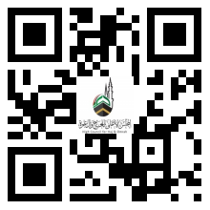 | 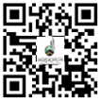 | https://wa.link/1l5j4a | https://ee.kobotoolbox.org/x/f5XMUHbC | ١. النيل الأبيض
 | 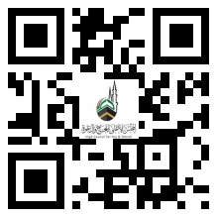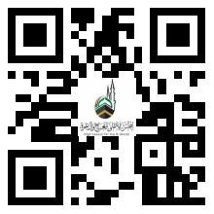 |  | https://wa.me/0912534274  https://wa.me/0912486451 |  | ٢. النيل الأزرق
 | 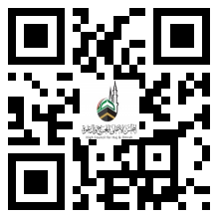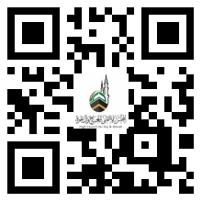 |  | https://wa.me/+249122887911  https://wa.me/+249915461634 |  | ٣. سنار
 | 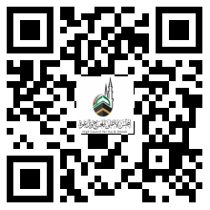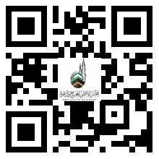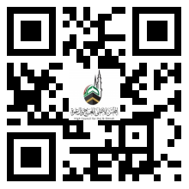 |  | https://wa.me/249113171046  https://‎wa.me/249910419404  https://‎wa.me/249129350372 |  | ٤. الشمالية
 | 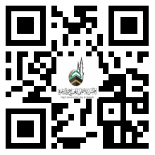 |  | https://wa.me/249917565821  https://wa.me/249111175319 |  | ٥. وسط دارفور
 | 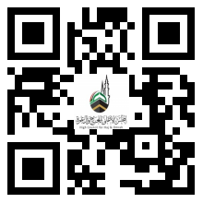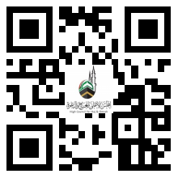 |  | http://wa.me/249122055700  http://wa.me/249123128277 |  | ٦. نهر النيل
 | 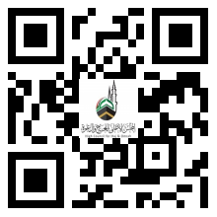 | 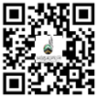 | https://wa.me/249111461119 | https://ee.kobotoolbox.org/x/prAex7wG | ٧. شمال كردفان
 | 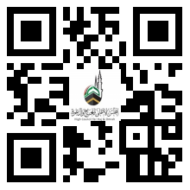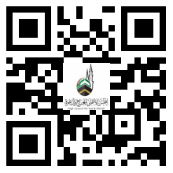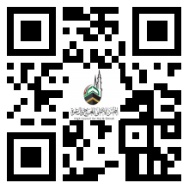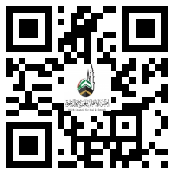 |  | https://wa.me/249120045996  https://wa.me/249120045997  https://wa.me/249120045998  https://wa.me/249900746981 |  | ٨. الجزيرة
 | 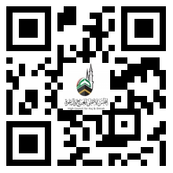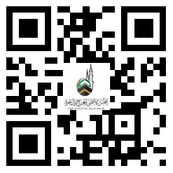 | 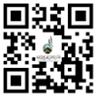 | http://wa.me/249912822054  http://wa.me/249912450502 | https://2h.ae/loEK | ٩. البحر الأحمر
 | 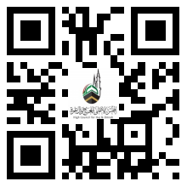 | 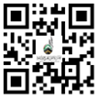 | http://wa.me/249911113411 | https://2h.ae/jMan | ١٠. الخرطوم
 | 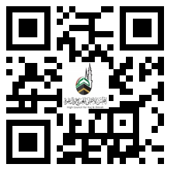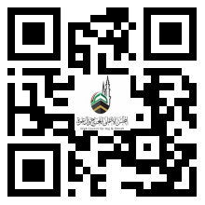 | 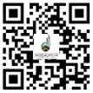 | http://wa.me/249123376553  https://wa.me/249911113411 | https://ee.kobotoolbox.org/x/3GPhh1NA | ١١. غرب كردفان
 | 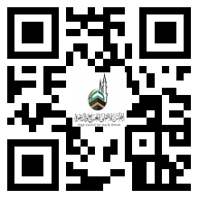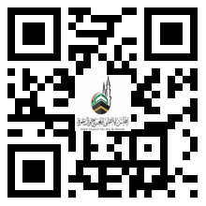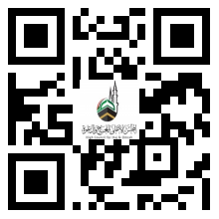 | 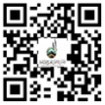 | https://wa.me/249912811921  https://wa.me/249912950042  https://wa.me/249122392121 | https://ee.kobotoolbox.org/x/fCL1QYDh | ١٢. كسلا
 | 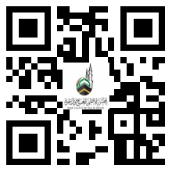 |  | https://wa.me/249965042597 |  | ١٣. شرق دارفور
 | 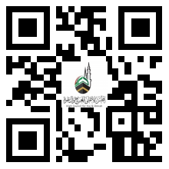 |  | https://wa.me/249919894488 |  | ١٤. شمال دارفور
 | 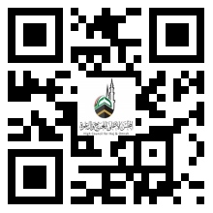 |  | https://wa.me/249129014122 |  | ١٥. جنوب دارفور
 | 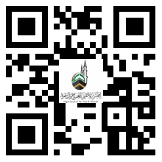 |  | https://wa.me/249123423606 |  | ١٦. جنوب كردفان
 | 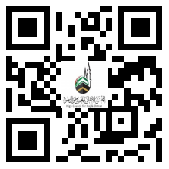 |  | https://wa.me/249111111998 |  | ١٧. غرب دارفور
 | 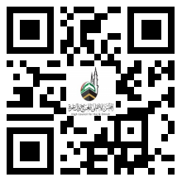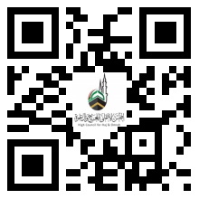 |  | https://wa.me/249918011391  https://wa.me/249112475491 |  | ١٨. القضارف

